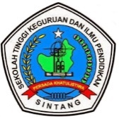
Development of discovery learning-based e-module in Islamic-integrated protist subject in MA

Salma Nada Laila ^{1*}, Nanik Lestariningsih ², Mukhlis Rohmadi ³

Department of Tadris of Biology, Faculty of Tarbiyah and Teaching, Institut Agama Islam Negeri Palangka Raya

*Corresponding author: salmanada2219@gmail.com and nanik.lestariningsih@iain-palangkaraya.ac.id

Article Info | ABSTRACT
Article History:  Received  Revised  Accepted  Published | The research identifies the validity and attractiveness of discovery learning-based e-module in Islamic-integrated protist subject developed. The research method employed is the research and development (R&D) with ADDIE (Analysis, Design, Development, Implementation, and Evaluation) model. The e-module validity test is carried out by 5 experts (2 material experts, 2 media experts, and a tafsir expert, whereas, the attractiveness test was conducted by a Biology teacher and Grade 10 students at MA Muslimat NU. Based on the result of the final stage of the validation, the developed e-module is valid with an average value (material expert = 3.46, media expert = 3.81, and tafsir expert – 3.79). The e-module attractiveness test by teachers generates an average value of 3.25 within a criterium of “very interesting”. Additionally, the result of students’ assessment of the e-module attractiveness resulted in an average value of 3.23 or within the “interesting” criteria.  Copyright © 2022, Laila, Lestaringingsih & Mukhlis  This is an open access article under the CC–BY-SA license
Keywords:
E-Module
Discovery Learning
Protist
Islamic Integration

Citation: Nada Laila, S., Leastaringsih, N., & Mukhlis Rohmadi. (2022). Development of discovery learning-based e-module in Islamic-integrated protist subject in MA. JPBIO (Jurnal Pendidikan Biologi), Vol(No), xx-yy. DOI: https://doi.org/10.31932/jpbio.vxix.xxx

INTRODUCTION
The current global demand requires education to keep abreast with technology development to improve education quality, especially to adjust its use in the education world, especially in the learning process (Budiman, 2017). In the 2013 Curriculum, the Regulation of the Minister of Education and Culture of the Republic of Indonesia No. 65 /2013 elaborates the Process Standard of Primary and Secondary Education that teachers are obliged to utilize information and communication technology in a learning process to improve teachers’ performance and, in turn, create an effective and efficient learning process (Pasaribu, 2019).
Enhancing teachers’ performance in creating an effective learning process requires the support of planning and implementation that lead to student teaching that utilizes technology and equips students so that they can keep up with technology development as a source of knowledge (Manalu, 2019). Changes that occurred in achieving the goals trigger the need of the education world for innovation and creativity in the learning process following the global demand of the 21st century (Budiman, 2017). One of the currently developed innovations is electronic learning or e-learning. E-learning is a learning activity innovation that is supported by the use of information and communication technology (Sole & Anggraeni, 2018). The learning activity emphasizes process skills and active learning; hence, the shift from textbook to non-textbook (electronic) teaching materials can facilitate students in both independent and conventional learning.
Directorate General of Primary and Secondary education, Department of National Education in 2003 stated that good and feasible teaching materials used in the learning process should have the following characteristics, namely self-instructional, self-contained, stand-alone, adaptive, and user friendly (Arsanti, 2018). In terms of the ideal teaching materials, one of the learning models, which is discovery learning-based teaching material has similarities to the ideal condition of a teaching material such as a module in which students could learn independently by finding the information needed to achieve learning objectives through self-collecting, -processing, and -analyzing data. In the field, however, there are teaching materials that have not met charactersitics and no teaching material innovation that follows technology advancement in a learning process.
The more advanced and rapid development of ICT, the more revealing is sciences contained in the Qur’an. This is evidence of the righteousness of Allah’s word contained in the Qur’an as a life foundation of humans. The role of integration of the Qur’an and Natural Science (IPA) in education has two important missions, namely the development of spiritual-moral and intellectual power for students. The integration of the Quran and IPA is a necessity since it is a source of knowledge that includes all aspects of life with an addition of science so that the education world could create a high-spirituality generation of thinkers (Harahap, 2018). Husna et al. (2020) stated that the Islamic-integrated IPA learning process could create unity in students’ understanding of a subject both in religious and science aspects. The problem at school, currently, is that no Islamic-integrated teaching materials are available, especially in Biology in the protist subject at MA Muslimat NU. Teachers tend to convey learning theories without integrating them with Quranic verses in online learning. Therefore, the teaching materials used need to add Quranic verses. This is supported by a learning objective at MA, which is improving religious knowledge to maintain Islamic values (Kurniati, 2016).
The discovery learning model-based teaching material is an innovation that requires students to be active including in independent learning. Its implementation in the module could invite students to identify the main concepts of a subject as the initial assignments of the studied subject (Putrayasa et al., 2014). This is strengthened by the research result of Putrayasa et al., (2014) stating that after the implementation of the learning model, students experienced a significant improvement in learning outcomes.
Based on the result of the need analysis, 82.6% of the students wanted teaching materials in the form of electronic with the expectation that the material could display clear images and attract students to learn. Teachers and 84% of the students agree to student worksheets that are developed in the form of discovery learning-based e-module in the Islamic-integrated protist content. Syafri (2019) opined that the developed model is a systematically compiled teaching material so that it can be used for independent learning with or without teacher explanation. The application of the discovery learning model in the module could also urge students to find the main concepts of the subject as the beginning of mastery of the studied subject since it includes learning activities that emphasize independence or group cooperation to find the subject concepts (Putrayasa et al., 2014). This is consistent with Bruner’s learning theory that the learning process runs well if the teacher provides opportunities to students to find concepts, theories, or content understanding independently (Ariana et al., 2020).
Based on the aforementioned, workable innovation in the learning process resulting from the need analysis is by developing a teaching material of discovery learning-based e-module in Islamic-integrated protist subject. The developed teaching material is expected to make students understand more about the learning subject that contains Islamic values thus it could produce good learning outcomes, especially in Biology subject in protist subject.

RESEARCH METHODS
Research Design
The current research and development was a type of research and development, namely a research method aiming at producing and developing a learning product. The analysis technique employed was qualitative and quantitative analyses. The research and development model of the e-module used in the research is an ADDIE development design model. The model consists of five stages, namely Analysis, Design, Development, Implementation, and Evaluation as illustrated in Figure 1 (Meilina et al., 2020) (Nancy, 2013). The research design was the ADDIE design model.
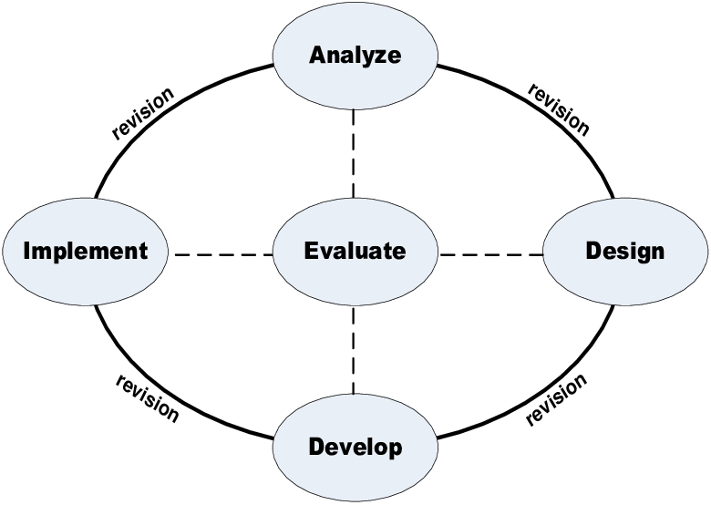
Figure 1. ADDIE Design Model

Population and Samples
The research samples consisted of biology teachers and Grade 10 students at MA Muslimat NU in the academic year of 2021/2022.

Instruments
The research employed two types of instruments, namely validation and attractiveness instruments. Table 1 indicates the data collection instruments in the research.
Table 1. Research Instruments
Type of Data | Respondents | Instrument
Product validation | Material expert  Design expert  Tafsir expert | Validation sheet
Product attractiveness | IPA teacher and  Grade 10 students | Response questionnaire

There were 5 validators used to assess and give input and suggestions on the e-module before its utilization in learning, namely 2 material experts, 2 media experts, and a tafsir expert. The material experts were selected based on a consideration that they had the competencies in the basic knowledge of the development of teaching materials and learning subject, especially in protist. The selection of the media experts followed a consideration that they had the competencies in learning media and teaching materials of learning modules, whereas the tafsir expert was selected since he is a lecturer in the field of study with a minimum a bachelor’s degree of education with expertise in tafsir.

Procedures
The procedure of the e-module research and development followed the stages in the ADDIE design model that consisted of Analysis, Design, Development, Implementation, and Evaluation.

Data Analysis
Questionnaire analysis in the research employed a Likert Scale of 1-4. Next, the average of the results was calculated using the following formula (Meilina et al., 2020).
$$Average=\frac{Total Score}{Total item}$$
The next step was calculating the validity and attractiveness level of the e-module using the following criteria.
Table 2. Qualification of the Validity and Attractiveness Level
Score | Validity and Attractiveness Level
3,25 ≤ P ≤ 4,00 | Good
2,50 ≤ P < 3,25 | Fair
1,75 ≤ P < 2,50 | Poor
P < 1,75 | Bad
The determination of interval distance (Ji) can be obtained using the following formula:
$$Ji=\frac{(t-r)}{JK}$$
Where:
t = The ideal highest score in the scale; 4
r = The ideal lowest score in the scale; 1
Ji = Total interval class; (4-1)/ 4 = 0.75

RESULTS
The product developed in the research was a Discovery Learning-based e-module in an Islamic-integrated protist subject. The research was R&D research that applied steps of the ADDIE (Analysis, Design, Development, Implementation, and Evaluation) design model. Steps carried out by the researchers in the research and development to obtain valid and interesting product are discussed as follow.
- Analysis
The first step in the research was analyzing the problems and needs of the to-be-developed product on Biology teacher and students of Grade X IPA. Need analysis was generated from the results of interviews, observation, documentation, and questionnaire dissemination to the teacher and students.
The result of the interview with the Biology teacher suggested that the methods used in face-to-face learning were still simple that included teacher center, question and answer, and discussion. These methods were deemed more effective and efficient in conveying the subject and saving learning time. However, the teacher experienced some obstacles at present, among others, challenges in conveying the subject in online learning. They struggled in differentiating which students were really active and which were not, which ones truly understood the subject taught and which ones did not. This difficulty was related to limitations in the learning process.
Based on the result of questionnaire distribution, 73.9% of the students found difficulties in understanding the protist content. This difficulty was also related to the online learning process and the teacher who conveys the subject or the facilitator became limited. 87% of the students looked for other learning sources, such as the internet, in addition to the school handbooks to help them in understanding the learning subject.
Students must learn the learning subject independently using the handbooks or student worksheets (LKS). The result of the analysis of LKS as a handbook used in learning indicated that the images contained in the book were unclear. The LKS only contains a table of content, instruction for use, learning activities in the form of assignments, biology subject in semester 1 that consists of several chapters, end of semester assessment, glossary, reference, and author profile. It does not contain other learning sources to help in understanding the subject matter. No answer key in the LKS let alone the link between Quranic verses and the learning subject. In addition, technology has not been fully applied in the process. The display of the LKS used in biology learning is illustrated in Figures 2, 3, and 4.

 | 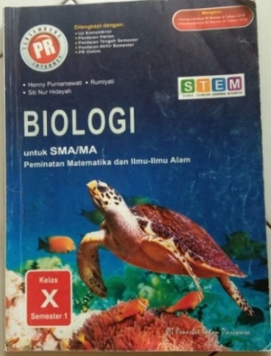  Figure 2. Display of LKS Cover | 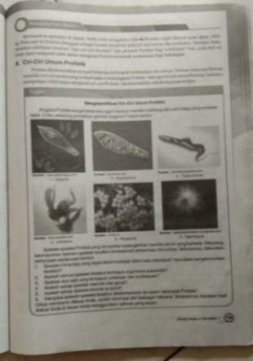  Figure 3. Display of Learning Activities | 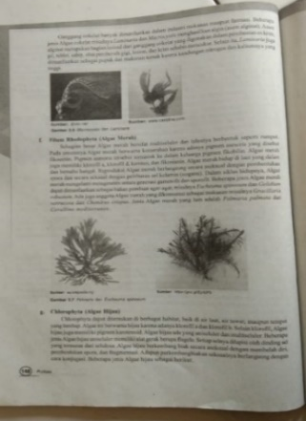  Figure 4. Display of learning content

Based on the above facts, the biology teaching material of LKS used in the school requires some improvements since it has not met the characteristics stated in the book writing guidance issued by the Directorate General of Vocational Schools and Primary and Secondary Education Department of National Education in 2003. Teaching materials, according to the guidance, must have the following characteristics: self-instructional, self-contained, stand-alone, adaptive, and user friendly (Wahyuni, 2017).
The results are consistent with the result of questionnaire distribution stating that 82.6% of the students wanted electronic teaching materials. The teacher and 85% of the students agreed to the developed teaching material in the form of a discovery learning-based e-module in Islamic-integrated protist subject. The developed e-module is aimed at independent learning with or without teacher explanation. The application of the discovery learning model in the module also invites students to find the main concepts of the subject as the beginning of mastery of the studied subject since the learning activities emphasize independence or group cooperation in finding the content concepts (Putrayasa, 2014)
- Design
The next stage was designing a product to be developed, which is a discovery-learning based e-module in Islamic-integrated protist subject. Steps taken during the stage included adjusting the subject to the Basic Competence, indicators, and learning objectives to be mastered.

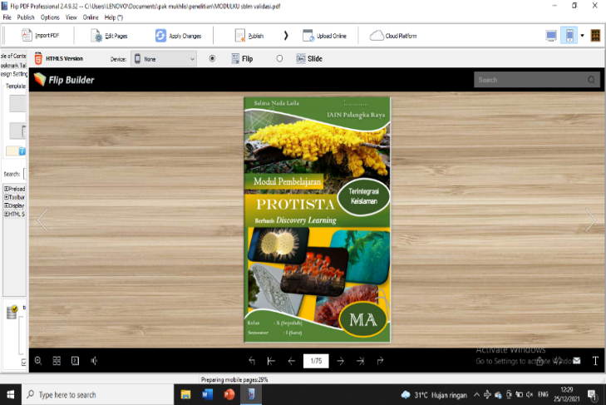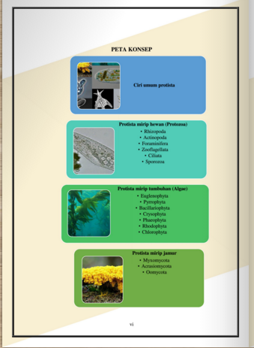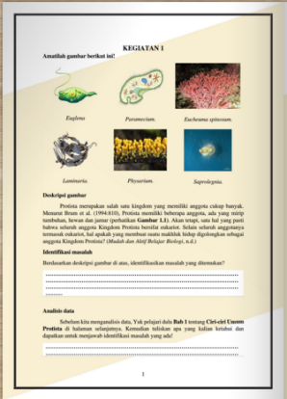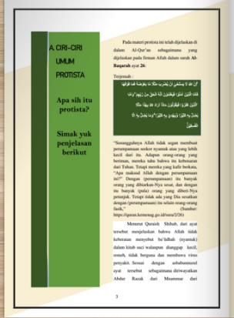
Figure 5. The initial design of the e-module

- Development
After designing the e-module, the next stage was development. The development stage was the process of developing the product, in this case, the e-module, using the Flip PDF Professional application so that the module can be presented online and freely accessed by users. What distinguishes the developed teaching material from the previous teaching material (LKS) is that the developed teaching material is in the form of an electronic module based on the discovery learning model, it integrates Islam and uses the Flip PDF Professional application, and the content is arranged in such a way to simplify students in understanding the subject and can be used as attractive teaching material. Moreover, the e-module will be on an online platform that facilitates students or users to access it anytime and anywhere.
Once the product development was completed, the next step would be the validation process by the experts. Validators involved in the development consisted of material experts, media experts, and a tafsir expert. The validation is aimed at generating validity data and supporting the e-module improvement. During the validation process, the researchers performed revisions I and II based on the experts’ input in the validation stage I and II.
The assessment questionnaire used by the material expert consisted of 41 question items that comprised 3 assessment aspects, namely feasibility of content, presentation, and language. The result of material expert validation is presented in Table 4.

Table 4. Result of Material expert Validation
No. | Stage 1 |  | Stage 2
No. | Validator 1 | Validator 2 | Validator 1 | Validator 2
Total score | 132 | 133 | 143 | 141
Max. Score | 164 | 164 | 164 | 164
Average | 3,22 | 3,24 | 3,49 | 3,44
Average | 3.23 |  | 3,46
Criteria | Fairly valid/ revision as needed |  | Valid/ no revision
Based on the validation result of the material experts in Table 4, after the revision based on the recommendation in stage I, the content validity in stage 2 in the discovery learning-based e-module in Islamic-integrated protist subject received an average of 3.46 or within the “valid” category. Therefore, it can be stated that the developed product is feasible to be used and tested on students.
In the media expert, questions of the questionnaire consisted of 32 items that included 4 assessment aspects of e-module size, cover design, content design, and language feasibility. The average score obtained from the assessment is presented in Table 5.
Table 5. Result of Media Expert Validation
No. | Stage 1 |  | Stage 2
No. | Validator 1 | Validator 2 | Validator 1 | Validator 2
Total score | 114 | 118 | 122 | 122
Max. Score | 124 | 124 | 124 | 124
Average | 3.56 | 3.69 | 3.81 | 3.81
Average | 3.63 |  | 3.81
Criteria | Valid/ no revision |  | Valid/ no revision
Based on the media expert validation result as indicated in Table 5, after the revision according to the stage 1 recommendation, the media validity in stage 2 of the discovery learning-based e-module in Islamic-integrated protist subject received an average of 3.81, which means that it was within the “valid” category. Therefore, the product developed is feasible for use and trial on students.
The questionnaire of the tafsir expert contained 19 question items. The average score received from the tafsir expert assessment is indicated in Table 6.

Table 6. Result of Tafsir Expert Validation
Description | Stage 1 | Stage 2
Total score | 59 | 72
Max. Score | 76 | 76
Average | 3.11 | 3.79
Criteria | Fairly valid/ revision as needed | Valid/ no revision
Based on the result of the tafsir expert validation in Table 6, revision carried out based on the stage 1 recommendation resulted in an average of the tafsir validation of stage 2 in the discovery learning-based e-module in the Islamic-integrated protist subject of 3.39 and within the “valid” category. Hence, it can be concluded that the developed product is feasible for use and trial on students.

- Implementation
The implementation stage was conducted by performing a large-scale product trial, which was the discovery learning-based e-module in the Islamic-integrated protist subject after the revision I and II were completed. The trial was conducted in Class X of MIPA semester 1 that consisted of 48 students who studied protist content. The trial was done by distributing questionnaires to students and teachers in Class X MIPA to generate data on the attractiveness of the developed e-module. Revision III was conducted after the large-scale trial according to the assessment of the product users, which were IPA teachers and students.
The number of questions in the attractiveness questionnaire was 28 items which consisted of 5 indicators of layout neatness, subject completeness and clarity, the suitability and clarity of supporting subject, grammar, and ease of use. Table 7 presents data on the result of the questionnaire on teacher’ and students’ attractiveness of the developed e-module.
Table 7. Result of E-Module Attractiveness by the Teacher
No. | Indicator | Score
1 | E-module layout neatness | 24
2 | E-module subject completeness and clarity | 28
3 | The suitability and clarity of the supporting subject | 12
4 | Grammar | 17
5 | E-module ease of use | 10
Total score |  | 91
Maximum score |  | 108
Average |  | 3,25
Criteria |  | Very Good/ Very attractive
Based on the data of the teacher’s response to the attractiveness of the discovery learning-based e-module in the Islamic-integrated protist subject in Table 7, the developed e-module is attractive to be used in the learning process. This was indicated by the teacher’s response that had an average of 3.25, which was within the very good/very attractive criteria.

Table 8. Result of E-Module Attractiveness by the Students
No. | Indicator | Score
1 | E-module layout neatness | 21.8
2 | E-module subject completeness and clarity | 31.8
3 | The suitability and clarity of the supporting subject | 10.3
4 | Grammar | 16.6
5 | E-module ease of use | 10
Total score |  | 90.5
Maximum score |  | 108
Average |  | 3,23
Criteria |  | Good/Attractive
Based on the data of the student’s response to the attractiveness of the discovery learning-based e-module in the Islamic-integrated protist content in Table 8, it can be seen that the developed e-module is attractive to be used in the learning process. This was indicated by the response result of 28 students with an average of 3.23 or within the criteria of good/attractive.
The discovery learning model in the e-module is in the learning activity pages. The learning activity pages contain syntax of the discovery learning model, namely stimulation by displaying related images or videos on the subject to be discussed along with their description, problem statement/identification, data collection, data processing, verification, and concluding/generalization.
- Evaluation
The evaluation stage is a process that aims at identifying whether or not the developed product has met the initial expectation and distinguishing the developed product’s validity and attractiveness. Based on the research, the evaluation process occurred in every stage of the ADDIE model for product revision or improvement requirement, namely in the Analysis, Design, Development, and Implementation stages; therefore, it is called a formative evaluation. In the Development stage, the evaluation was carried out through the product validation by the experts, whereas in the implementation stage, the evaluation was done through a large-scale trial to identify the product’s attractiveness. Figure 6 shows the final display of the e-module after revision.

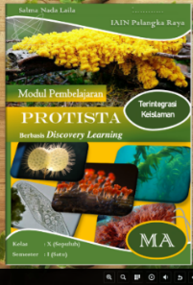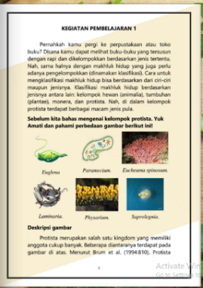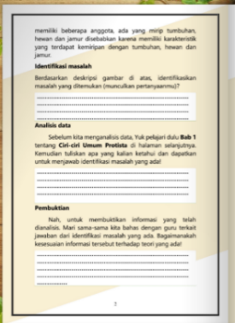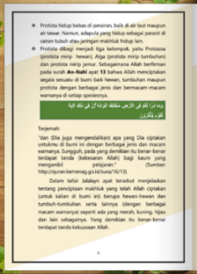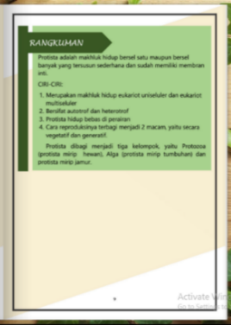
Figure 6. Final Display of the E-Module

DISCUSSION
In the current research, the researchers developed a product of discovery learning-based e-module that is used in the protist subject that includes the integration of Islam. The module was developed using the Flip PDF Professional application and put on an online platform to be accessed freely by the users. The e-module development was a type of research and development by applying the research and development stages of the ADDIE model (Analysis, Design, Development, Implementation, and Evaluation). According to (Muthalib et al., 2022) Mulyatiningsih (2012), the ADDIE model is a model that is deemed to have more rational and complete stages compared to other models; thus, the model can be used for various forms of product development such as the development of the discovery learning-based e-module. The steps in the e-module research and development until the generation of the valid and attractive final product is as follow.
  - Analysis
In this stage, the researchers carried out performance analysis and need analysis of students and teachers in the learning process at school. The interview results with the Biology teacher obtained that the methods used in the face-to-face learning were still simple, such as teacher center, question and answer, and discussion. The methods were considered effective and efficient in conveying the subject and saving learning time. However, the teacher experienced some obstacles at present, among others, challenges in conveying content in online learning. They struggled in differentiating which students were really active and which were not, which ones truly understood the content taught and which ones did not. This difficulty was related to limitations in the learning process. Muthalib et al., (2022) stated that changes in the learning implementation from face-to-face to online learning have the teachers unprepared in executing the process; therefore, the pandemic that requires the implementation of online learning becomes an issue in conveying the learning subject since teachers feel limited in conveying the content.
Based on the questionnaire distribution, 73.9% of the students rendered difficulties in understanding the protist content. The difficulty was also related to the online learning and the teacher who conveyed the content or the facilitator who became limited. This is similar to Hardigalu & Yeni, (2019) that the protist subject contains foreign terms that are hard to memorize and understand by the students, and the students, on average, struggle in learning and understanding the protist classification, phylum grouping, and in differentiating characteristics of each phylum. About 87% of the students looked for other learning sources in addition to the school handbook, such as the internet to help them in understanding the subject.
Students must learn the learning subject independently using handbooks or student worksheets (LKS). The result of the analysis of LKS as a handbook used in learning indicated that the images contained in the book were unclear. The LKS only contains a table of content, instruction for use, learning activities in the form of assignments, biology subject in semester 1 that consists of several chapters, end of semester assessment, glossary, reference, and author profile. The non-existence of answer keys in the teaching material less help in independent learning. According to Devie (2020), teaching materials that contain exercises and answer keys could help students in identifying their achievements; thus, it supports them in the independent learning process. The LKS has not contained a linkage between Quranic verses and the learning subject. Islamic-integrated IPA learning process could create unity in students’ understanding of a subject both in religion and science (Husna et al., 2020). The statement is supported by the learning objective of MA, which is improving religious knowledge to maintain Islamic values.
Based on the above facts, the biology teaching material of LKS used in the school requires some improvements since it has not met the characteristics stated in the book writing guidance issued by the Directorate General of Vocational Schools and Primary and Secondary Education Department of National Education in 2003. Teaching materials, according to the guidance, must have the following characteristics: self-instructional, self-contained, stand-alone, adaptive, and user friendly (Wahyuni & Puspari, 2017).
About 82.6% of the students wanted electronic teaching materials with the hope that they could display clear images that attract students to learn. The teacher and 85% of the students agreed to the LKS that is developed into a discovery learning-based e-module in Islamic-integrated protist subject. Syafri, (2019) opined that the developed module is a systematically prepared teaching material so that it can be used for independent learning with or without teachers’ explanation since images, audio, or videos could be inserted in the e-module and it can be used anytime and anywhere with a display similar to 3D flipbook. The application of the discovery learning model in the module also invites students to find the main concepts of the subject as the beginning of the mastery the studied subject since the learning activities emphasize independence or group cooperation in finding the subject concepts (Putrayasa et al., 2014). Consistent with Bruner’s learning theory that the learning process will run well if teachers provide opportunities for students to find concepts, theories, or content understanding independently (Ariana et al., 2020).
  - Design
The next stage after the analysis stage was product design. Steps taken in designing the to-be-developed e-module included adjusting the subject to the basic competencies, indicators, and learning objectives to be mastered. Further, designing the content to be presented in the e-module that was adjusted to each chapter or sub-chapter. The initial design related to the e-module preparation consisted of cover, introduction, table of content, concept map, instruction for use, Basic Competencies, indicators, learning objectives, discovery learning model-based learning activities, Islamic-integrated content deepening, summary, competence test, learning evaluation, reference, glossary, and author profile (Najuah et al., 2020). Najuah (2020) expressed that in module preparation, the framework selected is simple and suitable to student conditions and needs. Therefore, the e-module was developed to help student understand the learning subject in the independent learning process. Following the e-module design in the research by Marizal & Asri (2022), e-module design is based on a theory of e-module structure, namely introduction, learning activities, and evaluation. Next was preparing other supporting elements, such as cover, content description chart, introduction, table of content, instruction for use, reference, glossary, and so on.
  - Development
After designing the e-module, the next stage was development. The development stage is the process of developing the product that is started with a framework up to the final product. The product developed by the research referred to the previous teaching material, namely LKS. What distinguishes the developed teaching material from the LKS is that the researcher developed a teaching material is in the form e-module based on the discovery learning model, it integrates Islam and focuses only on one content, namely protist and it is arranged in such a way so that it is easy to understand by the students and the display Flip PDF Professional application. Moreover, the e-module will be on an online platform that facilitates students or users to access it anytime and anywhere. After the development process and the final product were obtained, the next stage was the validation process by the experts that consisted of 2 material experts, 2 media experts, and a tafsir expert. The validation stage aims at generating validity data of the developed e-module and finding out whether or not the e-module is valid or feasible to be tested on students (Marizal & Asri, 2022).
Data obtained in the validation process consisted of quantitative and qualitative data. The quantitative data are data taken from the numeric assessment questionnaire, whereas the qualitative data are data retrieved from comments and suggestions generally from the experts related to the e-module improvement.
In the process, the validation was conducted twice; therefore, the researcher performed revisions I and II based on the input from the experts to produce a valid end product. In the validation stages, some significant changes occurred in the developed e-module. The changes included in the application background part, inside cover, concept map, content, and the addition of questions in the competence test and learning evaluation. Once the validation process stage I and II were completed, data related to the e-module validity was obtained.
Based on the research results, the material, media, and tafsir validities of the protist content in the e-module stage II received an average score of 3.46, 3.81, and 3.79, respectively; hence, all of them are within the “valid” criteria.
  - Implementation
The implementation stage is a stage to test whether or not the developed teaching material could give a contribution to students effectively and efficiently (Asmayanti et al., 2020). The stage was conducted after the validation stage I and II were completed. It implemented the e-module in the learning process. The researchers had distributed the product to the IPA teacher and students and the teacher helped in directing the students in using the e-module as the material for independent learning. Indicators for the e-module attractiveness assessment included the e-module layout neatness that attracts students to learn using the e-module, the image illustration displayed in the e-module could facilitate the understanding of the subject, the e-module subject completeness and clarity that facilitates students in learning, exercises in the e-module are varied and following the learning objectives, grammar used in the e-module is communicative, and easiness and clarity in understanding sentences in the e-module. The result of the IPA teacher’s response received a score of 3.25 with “very good/very attractive” criteria, whereas the result of the students’ response generated an average score of 3.23 with “good/attractive” criteria.
Face-to-face time limitations affected the data collection system by the researchers; therefore, many students chose to fill the questionnaire data of the developed e-module attractiveness through files/photos. This was an obstacle for the researchers in collecting the research data. The discovery learning-based e-module demands students to be more active in finding concepts and subjects (Fransukma et al., 2020). Research by Vadilla (2022) found that the utilization of discovery learning-based teaching materials could enhance students’ science understanding and skills where students achieved an above-KKM average grade. In the current research, however, the online learning created difficulties and limitations in the use of the e-module, namely limitations in directing and monitoring students in learning and performing learning activities using the discovery learning model syntax that was included in the e-module; therefore, the e-module utilization by the students was less maximum.
According to (Apriani et al., 2021), the use of technology in education could help teachers in terms of transfer of knowledge but not in students’ character building. Therefore, teachers’ role as an educator cannot be replaced by technology development. As online learning does not always bring out positive aspects in the learning process. A solution that can be applied to overcome the issue is by maximizing the role of a teacher as a facilitator to help students’ understanding of the learning content both online and face-to-face.
  - Evaluation
Evaluation is a stage to identify whether or not the developed e-module is consistent with the initial expectation. The stage occurred in every other stage of the ADDIE model, namely in the stage of Analysis, Design, Development, and Implementation; therefore, this is called a formative evaluation. In the research, the evaluation stage was for product revision or improvement purposes. In the Development stage, the evaluation was carried out through the e-module validation by the experts, whereas in the implementation stage, the evaluation was done through a large-scale trial to identify the developed e-module attractiveness. The evaluation stage is aimed at identifying the validity and attractiveness of the developed e-module.
After passing through the stages in the ADDIE design models, the final product can be stated as valid and attractive. It is valid based on the validation result from the material experts, media experts, and a tafsir expert that had a high score (Handayani et al., 2020). The teaching material was prepared by following the module characteristics based on the regulation of the National Education Standards Board on module feasibility. The teaching material is published in the form of a Flip PDF Professional application-based file. In the e-module development, the researcher created a simple framework or structure that is suitable to the needs and condition of the students that require them to learn independently at home (Najuah et al., 2020).

CONCLUSION
The development of teaching material of the discovery learning-based e-module in the Islamic integrated protist subject in MA applies research and development steps of the ADDIE model (Analysis, Design, Development, Implementation, and Evaluation). The first stage of the research was analyzing the problems and needs of the to-be-developed product on Biology teachers and students of Grade X IPA. The next step was designing the product and followed by the development or the product developing process using an application of Flip PDF Professional until the product can be put on an online platform. Once the product has finished, the next stage was product validation by the experts. The e-module was valid according to the assessment of the material, media, and tafsir experts. The assessment of the material experts received an average score of 3.46, whereas the media expert was 3.81 and the tafsir expert was 3.79.
The implementation stage was carried out by performing a large-scale product trial after the revision was completed. Based on the research, the last stage, which was evaluation, was conducted in every ADDIE model stage for product revision or improvement, namely, in the Analysis, Design, Development, and Implementation; therefore, it is a formative evaluation. The result of the teacher’s response received an average of 3.25 with “very good/very attractive” criteria, whereas the students’ response resulted in an average of 3.23 with “good/attractive” criteria. The final result of the discovery learning-based e-module in the Islamic-integrated protist content can be seen through the following link: http://smodulprotista.online/
ACKNOWLEDGMENT (IF ANY)
The authors would like to thank all parties, validators, Biology teachers, Grade 10 students of MA Muslimat NU, and lecturers at IAIN Palangka Raya, who have helped in completing the research.

REFERENCES
Apriani, Y., Rusdiawan, R., Asrin, A., Fahruddin, F., & Muhaimi, L. (2021). Manajemen Pembelajaran Daring pada Masa Pandemi Covid-19 Di SD IT Lombok Tengah. Jurnal Ilmiah Mandala Education, 7(2). https://doi.org/10.36312/jime.v7i2.2056
Ariana, D., Situmorang, R. P., & Krave, A. S. (2020). Pengembangan Modul Berbasis Discovery Learning Pada Materi Jaringan Tumbuhan Untuk Meningkatkan Kemampuan Literasi Sains Siswa Kelas XI IPA SMA. Jurnal Pendidikan Matematika dan IPA, 11(1), 34. https://doi.org/10.26418/jpmipa.v11i1.31381
Arsanti, M. (2018). Pengembangan Bahan Ajar Mata Kuliah Penulisan Kreatif Bermuatan Nilai-Nilai Pendidikan Karakter Religius Bagi Mahasiswa Prodi PBSI, FKIP, UNISSULA. KREDO : Jurnal Ilmiah Bahasa dan Sastra, 1(2). https://doi.org/10.24176/kredo.v1i2.2107
Asmayanti, A., Cahyani, I., & Idris, N. S. (2020). Model ADDIE Untuk Pengembangan Bahan Ajar Menulis Teks Eksplanasi Berbasis Pengalaman. Seminar Internasional Riksa Bahasa, 259–267.
Budiman, H. (2017). Peran Teknologi Informasi Dan Komunikasi Dalam Pendidikan. Al-Tadzkiyyah: Jurnal Pendidikan Islam, 8(1), 31–43. https://doi.org/10.24042/atjpi.v8i1.2095
Fransukma, S., Rohmadi, M., & Yuliani, H. (2020). The Use of Based Animation Media in Discovery Learning- Straight-Motion Material: The Impact of Critical Thinking and Student Learning Outcomes. SNPF (Seminar Nasional Pendidikan Fisika), 0, Article 0. http://prosiding.unipma.ac.id/index.php/SNPF/article/view/1718
Handayani, I. S., Ayatusa’adah, A., & Lestariningsih, N. (2020). The Validity of Integrated Islamic Ethnobotany Textbooks Based on the 3D PageFlip Application. Biosfer: Jurnal Tadris Biologi, 11(2), 129–138. https://doi.org/10.24042/biosfer.v11i2.7494
Harahap, A. (2018). Integrasi Alquran dan Materi Pembelajaran Kurikulum Sains pada Tingkat Sekolah di Indonesia: Langkah Menuju Kurikulum Sains Berbasis Alquran. Jurnal Penelitian Medan Agama, 0(0), Article 0. http://jurnal.uinsu.ac.id/index.php/medag/article/view/3963
Hardigalu, B., & Yeni, L. F. (2019). Pengaruh Model Pembelajaran Core Disertai Mind Mapping Terhadap Hasil Belajar Siswa Pada Materi Protista. Jurnal Pendidikan Dan Pembelajaran Khatulistiwa, 8(11). https://jurnal.untan.ac.id/index.php/jpdpb/article/view/37298
Husna, A., Hasan, M., Mustafa, M., Syukri, M., & Yusrizal, Y. (2020). Pengembangan Modul Fisika Berbasis Integrasi Islam-Sains pada Materi Gerak Lurus untuk Meningkatkan Hasil Belajar Peserta Didik. Jurnal Pendidikan Sains Indonesia, 8(1), 55–66. https://doi.org/10.24815/jpsi.v8i1.15539
Kurniati, K. (2016). Pembelajaran cooperative learning tipe STAD mata Pelajaran Fikih di MA Muslimat NU Palangka Raya [Undergraduate, IAIN Palangka Raya]. http://digilib.iain-palangkaraya.ac.id/537/
Marizal, Y., & Asri, Y. (2022). Pengembangan Modul Elektronik Berbantuan Aplikasi Flipping Book PDF Professional Pembelajaran Menulis Teks Eksplanasi: Diglosia: Jurnal Kajian Bahasa, Sastra, Dan Pengajarannya, 5(1), 135–152. https://doi.org/10.30872/diglosia.v5i1.343
Meilina, F., Surahman, F., & Sari, M. (2020). Pengembangan Media Pembelajaran Berbentuk Miniatur Rumah Adat Pada Tema 7 Untuk Siswa Kelas IV SDN 002 Tebing Kabupaten Karimun. Jurnal Minda, 2(1), 44–51.
Muthalib, A., Lubis, A., Sinaga, I. permata S., & Mahrani. (2022). Problematika Pembelajaran Daring (Kesulitan Yang Dihadapi Guru Dan Siswa SMP Swasta Nur Ihsan). PENDALAS: Jurnal Penelitian Tindakan Kelas Dan Pengabdian Masyarakat, 2(1), 31–44.
Najuah, N., Lukitoyo, P. S., & Wirianti, W. (2020). Modul Elektronik: Prosedur Penyusunan dan Aplikasinya. Yayasan Kita Menulis.
Pasaribu, S. (2019). Pemanfaatan Media Teknologi Informasi Komunikasi Dalam Peningkatan Kinerja Guru Pendidikan Agama Islam. Studi Multidisipliner: Jurnal Kajian Keislaman, 6(2), 92–110. https://doi.org/10.24952/multidisipliner.v6i2.2087
Putrayasa, I. M., Drs. Syahruddin, S. P., & I Gede Margunayasa, S. P. (2014). Pengaruh Model Pembelajaran Discovery Learning Dan Minat Belajar Terhadap Hasil Belajar IPA Siswa. MIMBAR PGSD Undiksha, 2(1), Article 1. https://doi.org/10.23887/jjpgsd.v2i1.3087
Sole, F. B., & Anggraeni, D. M. (2018). Inovasi Pembelajaran Elektronik dan Tantangan Guru Abad 21. Jurnal Penelitian Dan Pengkajian Ilmu Pendidikan: E-Saintika, 2(1), 10–18. https://doi.org/10.36312/e-saintika.v2i1.79
Syafri, F. S. (2019). Pengembangan Modul Pembelajaran Aljabar Elementer Di Program Studi Tadris Matematika IAIN Bengkulu. CV. Zigie Utama.
Vadilla, N. (2022). Pengembangan E-LKPD Berbasis Model Discovery Learning Pada Materi Termokimia Untuk Mengukur Keterampilan Sains Siswa. Educenter : Jurnal Ilmiah Pendidikan, 1(3), 152–164.
View of Pelatihan Internet Dan Power Point Untuk Guru-Guru Di SMP N 1 Sleman. (n.d.). Retrieved 11 June 2021, from http://ejournal.sisfokomtek.org/index.php/jpkm/article/view/38/31
Wahyuni, H. I., & Puspari, D. (2017). Pengembangan Modul Pembelajaran Berbasis Kurikulum 2013 Kompetensi Dasar Mengemukakan Daftar Urut Kepangkatan dan Mengemukakan Peraturan Cuti. JPEKA: Jurnal Pendidikan Ekonomi, Manajemen dan Keuangan, 1(1), 54–68. https://doi.org/10.26740/jpeka.v1n1.p54-68

